The Internet of Things (IoT) has become increasingly ubiquitous during the past few years with the advent of ideas such as Smart Home, Smart Energy Grids, wearables and personal sensing devices, etc. Cisco has predicted that there will be over 50 billion such connected devices by 2020, as shown in the below chart.
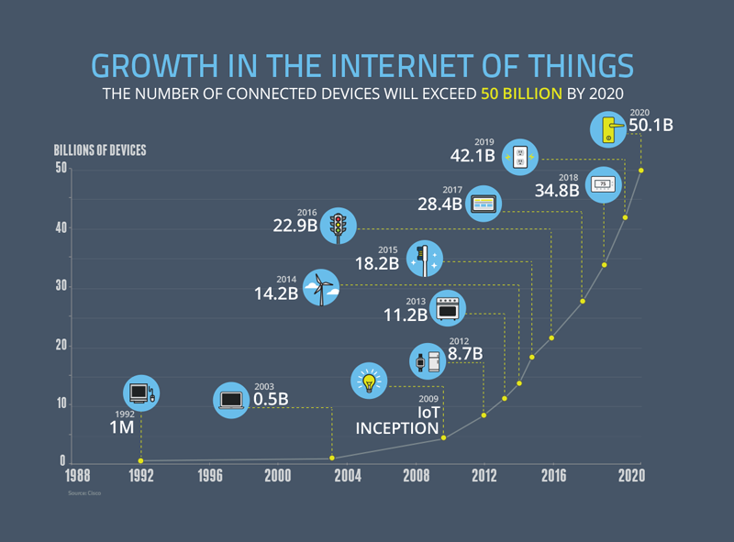

Most of these ‘things’ or IoT devices sense, measure, collect and act upon data for a specific application that they are designed for - such as ambient temperature control, vital health monitoring, environmental sensing, etc. Some of these applications deal with critical and sensitive information of a user, home, community or even a city. With deeper and deeper integration of these devices into the user’s environment, there is also a growing concern over the privacy of the data that is being collected or acted upon. Quite often, the data is also shared with other devices/things in the network, and frequently sent
for analysis and computation to a remote server in the cloud domain. The software on these remote servers processes the data and provides the smart devices with results that specify how they can act on the given data.

There are 3 aspects of current IoT systems that are the motivating factors for this project:
- Privacy of sensed/user data
Usually, the data collected by the smart devices is highly sensitive and often user-specific information. This could include things like number of people in a room, patient health monitoring, environmental data, etc. Sharing this data with a remote server leads to possible violation of the user’s privacy. If the data is compromised by anyone along the transmission channel, it enables them to easily identify the user with whom it is associated.

- Meaningful results and actions on sensed data
One of the critical functions of IoT systems is not only data collection, but acting on the sensed data. Quite often, participants in an IoT system may interact and share their information to collectively produce better results. Data obfuscation and encryption may be a possible way to guarantee user privacy. But it also prevents sharing of sensed data between different nodes in the system. Concealing any useful information that is part of the sensed data may prevent the system from providing useful results.

- Quicker inferences and responses by sensors
Since IoT systems are useful for critical and time-sensitive applications - such as health monitoring, automated vehicular systems, etc - it is important for them to generate inferences and responses in a timely manner. Transmission of data to a remote server for computation and processing hinders this aspect of the system and adds to the network overhead. In this regard, cloud computing is not a viable solution for such applications.

Based on the above reasoning, we can see that there is a need for a method of sharing sensed data between different nodes in the IoT system that preserves privacy of the data and provides quicker and accurate inferences from the data. The proposed solution is to use the ideas of fog computing and privacy-preserving machine learning. Fog computing addresses the problems of network overhead and remote computation that exist in the cloud computing paradigm and enables sharing of data between participants in the system in a transparent and effective manner. Privacy-preserving machine learning models help deduce results from collected data using deep learning, while ensuring that the presence of an adversary in the system does not compromise the privacy of the user data.

